**DAILY ONLINE ACTIVITIES SUMMARY**

|  |  |  |  |  |  |  |  |
| --- | --- | --- | --- | --- | --- | --- | --- |
| **Date:** | **01/06/20** | | | | **Name:** | **Harshitha M** | |
| **Sem & Sec** | **8th sem, A sec** | | | | **USN:** | **4AL16CS038** | |
| **Online Test Summary** | | | | | | | |
| **Subject** | | **SMS** | | | | | |
| **Max. Marks** | | **60** | | **Score** | | **60** | |
| **Certification Course Summary** | | | | | | | |
| **Course** | **Python for Machine Learning** | | | | | | |
| **Certificate Provider** | | | **Great Learning** | **Duration** | | | **5 hrs** |
| **Coding Challenges** | | | | | | | |
| **Problem Statement: 1) Given an array of positive integers.Write a c program to find the leaders in the Array** | | | | | | | |
| **Status: Completed** | | | | | | | |
| **Uploaded the report in Github** | | | | **Yes** | | | |
| **If yes Repository name** | | | | **Harshitha-M** | | | |
| **Uploaded the report in slack** | | | | **Yes** | | | |

Online Test Details:

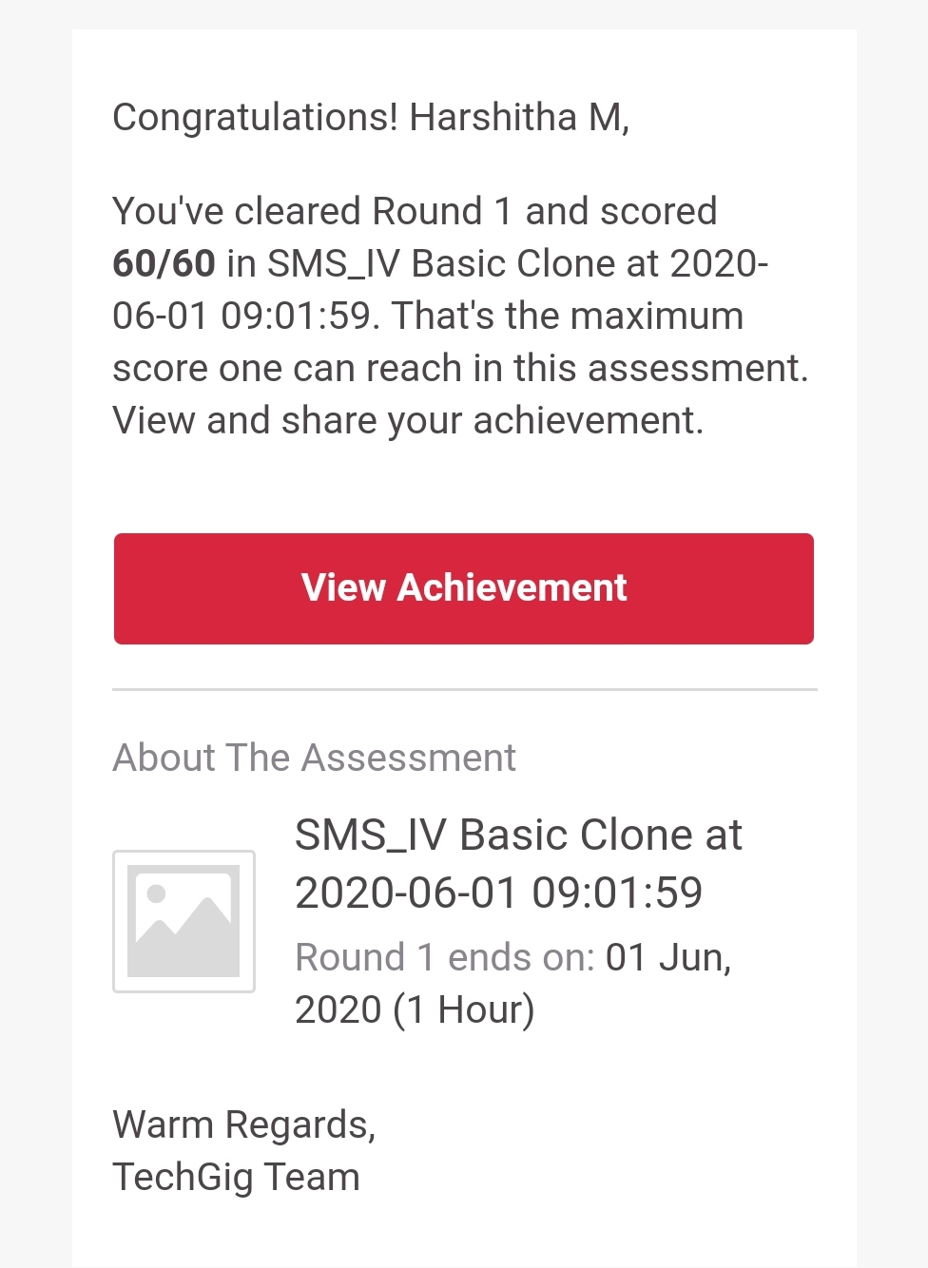

Certification Course Details:

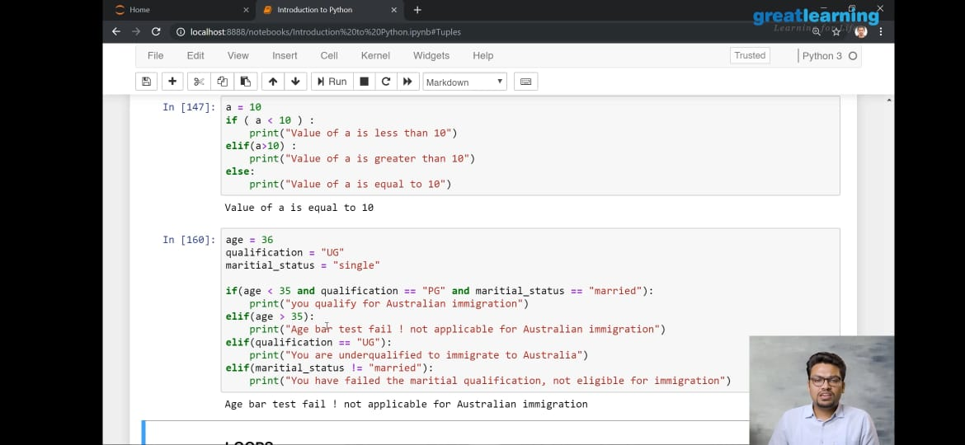

Coding Challenges Details:

1)

**#include <stdio.h>**

**int main()**

**{**

**int num,i,j,count=0;**

**scanf("%d",&num);**

**int arr[num];**

**for(i=0;i<num;i++)**

**{**

**scanf("%d",&arr[i]);**

**}**

**for(i=0;i<num;i++)**

**{**

**count=i;**

**for(j=i+1;j<num;j++)**

**{**

**if(arr[i]>=arr[j])**

**{**

**count++;**

**}**

**if(count==num-1)**

**{**

**printf("%d ",arr[i]);**

**}**

**}**

**}**

**printf("%d",arr[num-1]);**

**return 0;**

**}**